Supplementary Figure 2. Representative Western blot images of iNOS (130 kDa) and

β-tubulin (55 kDa) obtained from pooled lysates

IL-1β, 8 h, Western blotting Lot.YS748

IL-1β
Fraction Concentration

(A B C: µg/mL)
-

A

0 20 0 5

A

10 20 40
+

B

80 160 400

C

800

iNOS
(130 kDa)

β-Tubulin
(55 kDa)

111

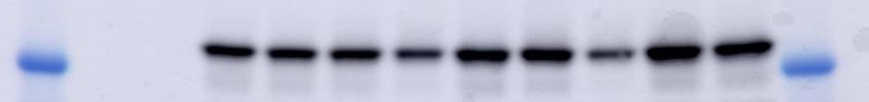
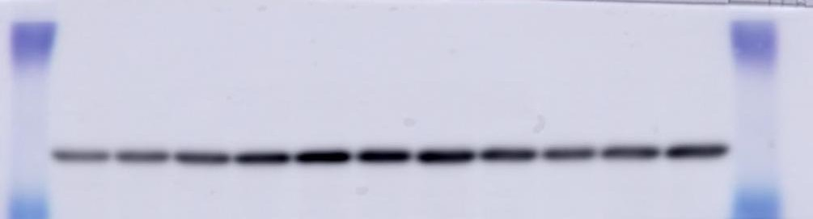
85

48

1× protease inhibitor cocktail in SDS sample buffer

iNOS exposure time（60 sec）
一Primary antibody : mouse monoclonal antibody against rat iNOS
(1:1000) (Thermo Fisher Scientific, Waltham, MA, USA)
二Secondary antibody : horse radish peroxidase-conjugated anti-mouse IgG (1:5000) for iNOS (Cell Signaling Technology Inc., Danvers, MA,
USA)
β-Tubulin exposure time（300 sec）
一Primary antibody： rabbit polyclonal antibody against rat β-tubulin (1:1000)
(Cell Signaling Technology Inc., Danvers, MA, USA).
二Secondary antibody： horse radish peroxidase-conjugated anti-rabbit IgG
(1:1000) for β-tubulin (Cell Signaling Technology Inc., Danvers, MA, USA).

